# Community-level study of ticks in a major cattle market in Edo State reveals high tick diversity but no species-specific preference for predilection site

# Anthony Osarobo Omoregie*, Emmanuel Nosa Osawe, Nicholas Olatunde and Afegbodi Blessing Obaitan

# Department of Animal and Environmental Biology, Faculty of Life Sciences, University of Benin, Benin City, Nigeria

# *Corresponding Author: [anthony.omoregie@uniben.edu](mailto:anthony.omoregie@uniben.edu)

# ABSTRACT

# Ticks are important ectoparasites affecting livestock worldwide, serving as vectors of diseases that challenge traditional livestock farming. Most studies on tick infestations in Nigeria are focused on population-level assessments, providing limited insights into co-infestation and assemblage patterns on their host. In this study, we estimated ixodid tick diversity and abundance at a major cattle market in Edo State, Nigeria, following community-level methods which would give further insight to their predilection preference by life stage, sex and species of tick. We employed a cross-sectional survey from January to March 2024, collecting tick samples from 96 cattle. A total of 1,930 ticks (1,689 adults, 241 nymphs; Among adults: 1570 females and 119 males) were collected, belonging to four genera (*Amblyomma, Rhipicephalus, Haemaphysalis*) and 13 species.Though, Species accumulation curve and a Jacknife 2 estimator indicated a tick species richness of at least 15. *R. annulatus, R. decoloratus, and R. geigyi* were the most abundant, accounting for over 92% of ticks collected. Permutative Multivariate Analysis of Variance tests showed significant differences (p < 0.001) in tick community composition when compared by sex and life stage but not by predilection sites. Also, a Factor Analysis of Mixed data did not reveal species-specific preference for any predilection site. Furthermore, Margalef indices of tick diversity were not significantly different (P>0.05) in all predilection sites. Given the role of cattle trade in spreading ticks across regions, our findings suggest the need for broader tick surveillance in Edo State due to the potential underrepresentation of abundance and diversity. Also, the lack of species-specific predilection suggests control strategies should target all host body parts.

# KEYWORDS: Ixodid ticks, Tick diversity, Tick abundance, Tick predilection sites, Cattle market

# INTRODUCTION

Ticks are major ectoparasites of livestock, acting as vectors for diseases that challenge traditional farming. Infestations lead to discomfort, physical damage, weight loss, reduced productivity, and heightened susceptibility to infections [1-3]. They transmit diseases like anaplasmosis, babesiosis, theileriosis, and rickettsiosis, significantly affecting livestock health and economic output [4]. In West Africa, *Amblyomma variegatum* and *Rhipicephalus microplus* are prominent species, contributing to the spread of diseases like heartwater caused by *Ehrlichia ruminantium* [5-7]. The severity of tick-induced harm varies by life stage, sex, and feeding capacity.

Tick life stages impact hosts differently due to variations in transmission potential. Adult ticks, being larger than nymphs, consume more blood and cause greater discomfort [8]. Male and female ticks also vary in their effects; females cause significant irritation, inflammation, and secondary infections, while their reproductive capacity exacerbates infestations and disease transmission [2,9,10]. Additionally, sex-specific microbiota differences influence the diseases they transmit [10-11].

Evidence suggests tick species exhibit preferences for specific predilection sites on livestock hosts. For instance, *Amblyomma variegatum* frequently targets the mammary area, often causing severe wounds and reduced milk production [12-14]. Such preferences are influenced by factors like attachment ability, host species, hair density, body temperature, proximity to blood vessels, evolutionary traits, and environmental conditions [11,15,16]. These tendencies may lead certain tick taxa, sexes, or life stages to favor specific body regions, altering community dynamics and site-specific infestations.

Livestock farming, particularly cattle trading, plays a vital economic and cultural role in Nigeria, contributing significantly to the Agricultural Gross Domestic Product (GDP) [17]. The sector generates employment, fosters inter-ethnic relations—dominated by Hausa traders—and provides essential products like meat, hides, and milk [18]. Most cattle in southern Nigeria are sourced from the northern states, where they are bred before transportation [19]. Livestock farming also sustains rural livelihoods and supports income generation [19]. However, tick infestations impose severe economic burdens through reduced productivity and disease transmission. These issues stem from prolonged attachment periods and the role of ticks as vectors of veterinary pathogens. Despite the significant challenges posed by ticks, control measures remain largely uncoordinated and insufficient [20,21]

The diversity and abundance of cattle ticks in Nigeria remain poorly studied. While some research has assessed tick prevalence at predilection sites, species-specific preferences have not been investigated. Additionally, many significant tick vectors are inadequately monitored. For instance, the invasive Brazilian tick, *Rh. microplus*, was first reported in high numbers in Edo State, Nigeria, by Adane *et al*. [22]. However, follow-up studies to monitor its persistence or investigate its spread remain scarce. This highlights a critical data gap needed for effective tick control, especially for livestock of significant economic importance to Nigeria.

Most studies on ticks in Nigeria have focused on population-level assessments, providing limited insights into co-infestation patterns and community-level structures. Comprehensive studies employing multivariate community-level approaches are essential to addressing these gaps. Understanding tick distribution and community structures can inform control measures, enhance disease management strategies, and support pest regulatory agencies in mitigating tick-borne diseases [23-24]. In this study, we aimed to address knowledge gaps on tick infestations in Edo State, Nigeria, by estimating Ixodid tick diversity and abundance in a major cattle market, examining the community-level structure of ticks across predilection sites on cattle, and investigating whether specific tick species, life stages, or sexes exhibit preferences for particular predilection areas.

# MATERIALS AND METHOD

# DESCRIPTION OF STUDY AREA

The study was conducted at the Federal Government College Road cattle market in Egor Local Government Area (LGA), Benin City, Edo State, Nigeria. This market is the largest in Egor LGA by size and volume of cattle traded, ranking third in Edo State. It serves customers from Benin City and surrounding regions. The site is geographically located at 6.38861°N latitude and 5.62611°E longitude.

Benin City, the capital and largest city of Edo State, is situated in Nigeria's South-South geopolitical zone. As of the 2006 national census, it had a population of approximately 1,363,975 [25] and lies at an average elevation of 78 meters above sea level [26]. Positioned in the humid tropical rainforest belt of Nigeria, the city experiences a tropical monsoon climate with two distinct seasons: a wet season (April to September) characterized by heavy rainfall and high humidity, and a dry season (October to March) marked by lower humidity and sparse rainfall. The annual precipitation averages 2,679 mm (105.5 inches).

**STUDY POPULATION**

The study population comprised both male and female cattle at the Federal Government College Road cattle market in Benin City. The observed cattle included various varieties of the Zebu breed (*Bos* *indicus*), such as Bokolo, Abore, Bunaji, and Ambala. These cattle were primarily transported for sale in southern Nigeria from northern regions of the country, including Taraba, Adamawa, and Abuja, as well as from neighbouring countries such as Chad and Cameroon. They exhibited a wide range of ages. The cattle predominantly relied on extensive grazing, feeding on natural grasslands to meet their nutritional needs.

**SAMPLING AND DATA COLLECTION**

A comprehensive cross-sectional field survey was conducted during the dry season, spanning January to March 2024. Ticks were collected from 6 predilection sites including head, neck, shoulder, belly, legs and tails, on the body of cattle using the hand-picking method (Fig. 1).Collected **t**icks were introduced into labelled sample bottles containing mixture of 70% ethanol and 10% glycerol (1:1) as preservative. The samples were examined under a dissecting microscope to determine their identification based on their morphological characteristics in the Department of Animal and Environmental Biology, Faculty of Life Sciences, University of Benin, Benin City, Nigeria. The ticks were identified to their genus and species using gross external morphological keys [27, 28]. The sex and stage of development of the ticks were also recorded.

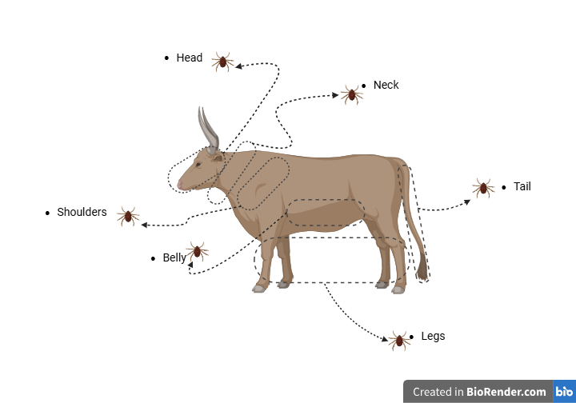

**Fig. 1** Schematic representation of the cattle predilection site where ticks were sampled for this study

## STATISTICAL ANALYSIS

For this study, we used the R software (Version 4.4.0) and Paleontological Statistics (PAST) Version 4.03 software [29] to analyse the tick data we collected. All data aggregation and manipulation was done in R.

Percentage prevalence of ticks among the cattle surveyed was done using the formula:

Prevalence (%) = Number of infected host x 100

Number of examined host 1

Overall, species richness was estimated using the Chao 2 and Jacknife 2 estimators. In addition, a species accumulation curve (SAC) was used to visually show how much sampling effort influences the observed species richness. All species richness estimations were calculated in PAST Software. We calculated the tick prevalence (%) by calculating the percentage of infested cattle from the total number of cattle examined.

Margalef indices at each predilection site for individual cattle were calculated using PAST software as a measure of the species richness of each tick community.

Margalef index: *D = (S - 1) / ln(N)*

Where: *D* is the Margalef Index; *S* is the total number of species; *N* is the total number of individuals; *ln* is the natural logarithm.

A negative binomial model compared ticks' mean abundance and species richness across all cattle predilection sites. This was computed using the ‘glm.nb()’ function of the “MASS” package in R [30]. As a post hoc to assess significant differences in abundance and across each predilection site, Tukey tests (α = 0.05) for multiple comparisons were computed using the ‘glht()’ function from the "multcomp" package [31], given the existence of five distinct habitat levels. Also, a Kruskal-walis test was computed on the calculated Margalef index to compare its difference across all predilection sites, using the ‘kruskal.test()’ function in the “dunn.test” package.

Non-metric Multidimensional Scaling (NMDS) was used to analyze and visualize the overall dissimilarity of the tick community at the cattle predilection sites, using the Bray-Curtis coefficient to create similarity matrices. Two dimensions adequately captured the pattern in the data. We employed Permutative Analysis of Variance (PERMANOVA) to check for significant changes in the tick community compositions for Sex, life stage and predilection sites, determined through 9999 permutations using the ‘adonis2()’ function from the “Vegan” package in R. As a post hoc, we used the ‘pairwise.adonis()’ function to check for significant differences (α = 0.05) between communities. Also, we tested for homogeneity of multivariate dispersion, which is a good way to represent the tick community variance between the predilection sites of the cattle. This was done using the ‘betadisper()’ function of the “Vegan” package.

To ordinate the preference of ticks by taxon, sex, developmental stage, and predilection site, we used a Factor Analysis of Mixed Data (FAMD). The data included qualitative variables (sex, predilection site, and tick life stage) and quantitative variables (abundance of each tick species). FAMD reduces the dimensionality of complex multi-dimensional datasets by projecting them into a principal component (PC) subspace, which can be visualized as a point cloud. In this space, the proximity of two points indicates their overall similarity based on the selected PCs. The FAMD was performed using the "FactoMineR" package [32].

# RESULTS

**3.1. Prevalence, abundance and relative abundance of ticks**

In this survey, 75 out of 95 sampled cattle were infested with at least one tick species, indicating an overall tick prevalence of 78.95%. Tick-infested cattle had a median of three distinct tick species. A total of 1,930 ticks were collected, comprising 1,689 adults and 241 nymphs. Of the adults, there were 1570 females and 119 males. Ticks were found across six predilection sites: belly (432), head (356), legs (417), neck (282), shoulder (99), and tail (344).

Three ixodid tick genera—*Amblyomma*, *Rhipicephalus*, and *Haemaphysalis*—were identified, consisting of 13 species (Table 1). The most prevalent species were *R. annulatus* (65.26 %), *R. decoloratus* (72.63 %), and *R. geigyi* (66.32 %) (Fig. 2). These three species were also the most abundant, accounting for 42.38 %, 29.38 %, and 20.93 % of the total ticks, respectively, and constituted over 92% of ticks collected from all positive cattle. Rare ticks, including an unidentified *Amblyomma* sp*.* and *Rhipicephalus* sp., were observed with a prevalence of 1.05% each.

**Table 1:** Tick species relative abundance (%) in all cattle predilection site investigated.

|  |  |  |  |  |  |  |  |
| --- | --- | --- | --- | --- | --- | --- | --- |
|  | **Predilection sites (%)** | | | | | | |
| **Predilection** | **Belly** | **Head** | **Leg** | **Neck** | **Shoulder** | **Tail** | **Overall** |
| ***A. variegatum*** | 0.36 | 0.31 | 0.78 | 0.21 | 0 | 0.78 | 2.44 |
| ***A. cohaerens*** | 0.05 | 0.1 | 0.1 | 0.1 | 0 | 0.1 | 0.47 |
| ***R. annulatus*** | 11.04 | 6.89 | 9.07 | 6.11 | 1.09 | 8.19 | 42.38 |
| ***R. decoloratus*** | 6.79 | 5.18 | 7.25 | 3.78 | 2.28 | 4.09 | 29.38 |
| ***R. geigyi*** | 3.89 | 3.83 | 4.15 | 3.99 | 1.45 | 3.63 | 20.93 |
| 1. ***leachi*** | 0 | 0.05 | 0 | 0 | 0 | 0.1 | 0.16 |
| ***R. lunulatus*** | 0.1 | 0.47 | 0.21 | 0 | 0.21 | 0.36 | 1.35 |
| ***R. muhsamae*** | 0.05 | 0.26 | 0.05 | 0.05 | 0 | 0.1 | 0.52 |
| ***R. senegalensis*** | 0.05 | 0.1 | 0 | 0.05 | 0 | 0.1 | 0.31 |
| ***Rhipicephalus* sp.** | 0 | 0 | 0 | 0 | 0 | 0.16 | 0.16 |
| ***R. sanguineus*** | 0.05 | 0.57 | 0 | 0.16 | 0 | 0 | 0.78 |
| ***R. guilhoni*** | 0 | 0.62 | 0 | 0.16 | 0.1 | 0.21 | 1.09 |
| *Amblyomma* sp*.* | 0 | 0.05 | 0 | 0 | 0 | 0 | 0.05 |
|  |  |  |  |  |  |  |  |

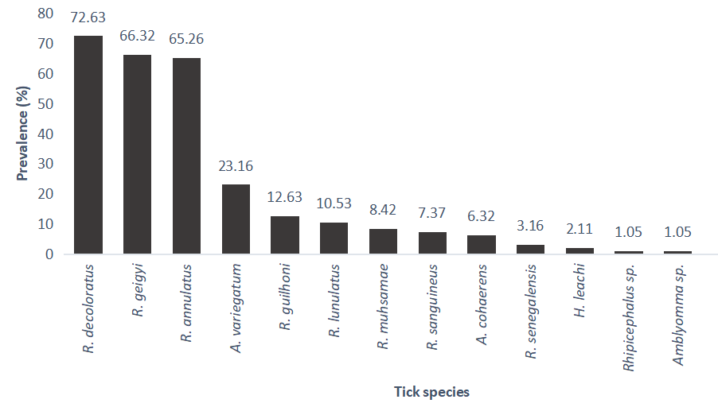

**Fig. 2** Tick species infestation prevalence (%) across all 95 cattle sampled.

**3.2. Tick community composition at the predilection areas**

The tick community composition at the predilection sites is illustrated in the NMDS plot (Fig. 3). The plot indicates significant overlap in tick composition and dispersion across the six predilection areas. Consistent with the NMDS plot, the PERMANOVA test showed no significant differences (p > 0.05) in the overall tick community structure among the predilection sites. Similarly, the test for homogeneity of dispersion revealed no significant differences (p > 0.05) between the sites. Non-significant variations in tick community composition across the predilection sites are detailed in Table 2.

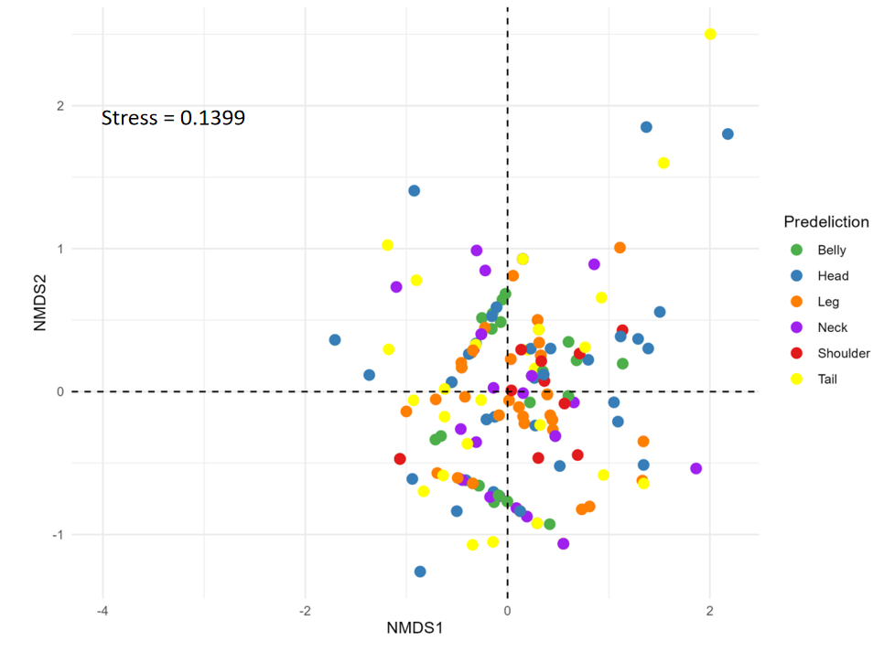

**Fig. 3** Non-metric multidimensional scale (NMDS) plot showing points representing the tick community in predilection sites. Points are coloured according to predilection sites.

**Table 2** PERMANOVA test comparing the community structure of ticks at the predilection sites

|  |  |  |  |  |
| --- | --- | --- | --- | --- |
| **Predilection Pairs** | **F.Model** | **R-Squared** | **p.value** | **p.adjusted** |
| **Belly vs Head** | 1.834 | 0.016 | 0.119 | 1 |
| **Belly vs Leg** | 0.082 | 0.001 | 0.951 | 1 |
| **Belly vs Tail** | 0.752 | 0.007 | 0.577 | 1 |
| **Belly vs Neck** | 0.39 | 0.004 | 0.757 | 1 |
| **Belly vs Shoulder** | 2.854 | 0.035 | 0.031 | 0.465 |
| **Head vs Leg** | 1.177 | 0.01 | 0.348 | 1 |
| **Head vs Tail** | 0.779 | 0.007 | 0.565 | 1 |
| **Head vs Neck** | 1.029 | 0.01 | 0.398 | 1 |
| **Head vs Shoulder** | 1.325 | 0.017 | 0.256 | 1 |
| **Leg vs Tail** | 0.608 | 0.005 | 0.691 | 1 |
| **Leg vs Neck** | 0.303 | 0.003 | 0.832 | 1 |
| **Leg vs Shoulder** | 1.429 | 0.017 | 0.209 | 1 |
| **Tail vs Neck** | 0.373 | 0.004 | 0.835 | 1 |
| **Tail vs Shoulder** | 2.213 | 0.031 | 0.08 | 1 |
| **Neck vs Shoulder** | 2.107 | 0.032 | 0.091 | 1 |

**3.3. Male and Female Tick community composition.**

The tick community structure by sex is illustrated in the NMDS plot (Fig. 4). The plot indicates that male ticks exhibit greater dispersion and heterogeneity compared to the relatively homogenous female ticks. PERMANOVA analysis revealed a significant difference (p < 0.001) in the community structure between male and female ticks. Similarly, the test for homogeneity of dispersion showed significant differences (p < 0.001) between the sexes.

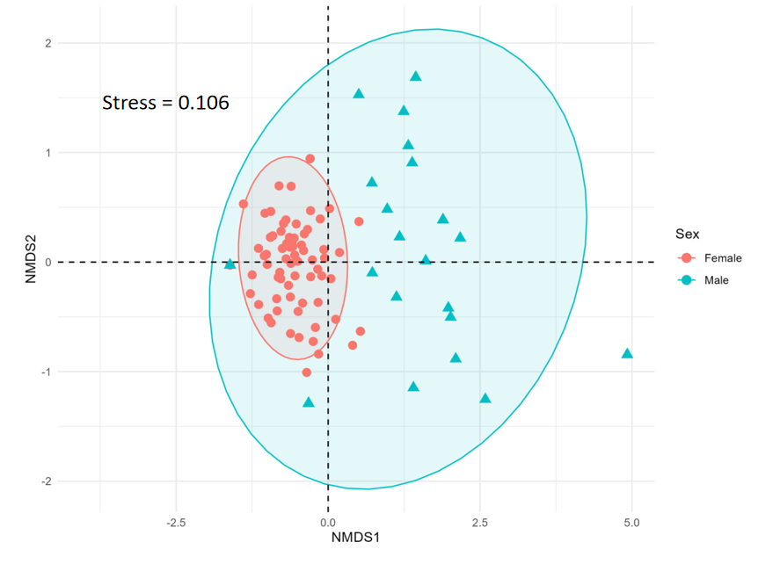

**Fig. 4** Non-metric multidimensional scale (NMDS) plot showing points representing the adult tick community across the cattle predilection sites. Points are coloured according to tick sex.

**3.4. Tick life cycle stage and community composition.**

Two life cycle stages, nymph and adult, were identified. The NMDS plot (Fig. 5) illustrates the community structure of both stages. PERMANOVA analysis revealed a significant difference (p < 0.001) in the community composition between the two stages. However, the test for multivariate dispersion showed no significant difference (p > 0.05) between the stages.

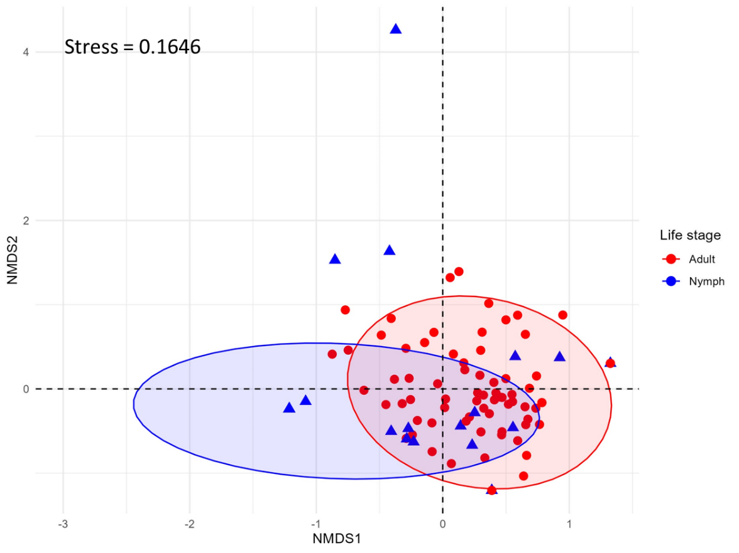

**Fig. 5** non-metric multidimensional scale (NMDS) plot showing points representing the tick community in predilection sites. Points are coloured according to tick life stage.

The most abundant ticks, including *R. annulatus*, *R. decoloratus*, and *R. geigyi*, were well represented across all predilection sites of the cattle (Fig. 6). *A. cohaerens* and *A. variegatum* were observed in all predilection sites except the shoulders. *Amblyomma* sp*.* and *Rhipicephalus* sp. were each restricted to a single predilection site—head and tail, respectively. *H. leachi* was found only on the head and tail of the cattle (Fig. 6).

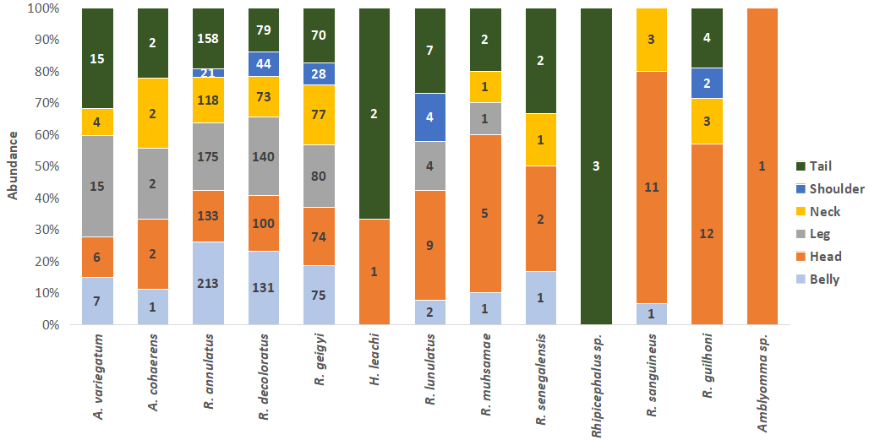

**Fig. 6** Abundance of tick species at each predilection site of cattle. Numbers embedded on the bars represent actual counts of the species.

**3.5. Species richness and taxonomic diversity of ticks**

Fig. 7 illustrates the species accumulation curve (SAC) estimating the species richness of ticks sampled at the cattle market. The observed number of tick species was 13. However, the SAC exhibits a mild upward trend, indicating that additional sampling of ticks from more cattle in the market would likely reveal further species. This trend is supported by species richness estimates: the Chao 2 method predicts 13 species, while the Jackknife 2 method suggests 15 species in the area.

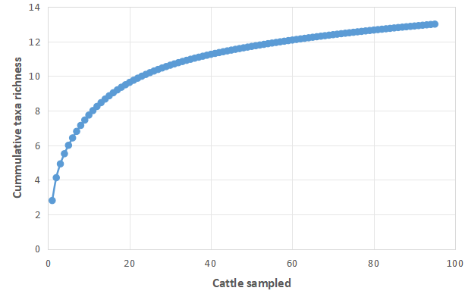

**Fig. 7** Species accumulation curve (SAC) of ticks sampled from 95 cattle in the market.

Fig. 8 depicts the overall tick abundance across predilection areas. The belly exhibited the highest mean abundance (7.32 ± 0.62), followed by the leg (6.51 ± 0.68), neck (6.13 ± 0.64), head (6.03 ± 0.55), and tail (5.49 ± 0.77). The shoulders had the lowest tick abundance, with a mean of 4.30 ± 0.55. The negative binomial model indicated that tick abundance on the shoulders was significantly lower (p < 0.05) compared to the belly.

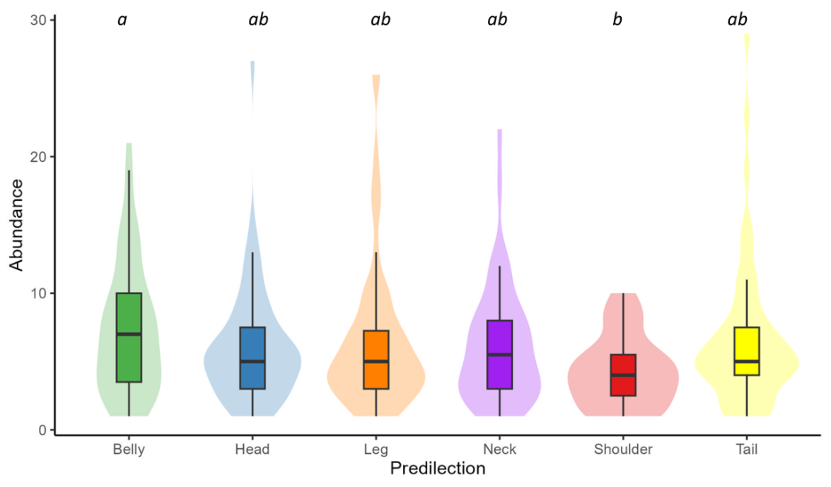

**Fig. 8** Abundance of ticks at the predilection areas in cattle sampled. Different letters show significant differences between predilections.

The median species richness across all predilection sites was two (Fig. 9). While variation in tick richness was not significant, the head exhibited the highest mean tick-species richness (2.42 ± 0.55), followed by the tail (2.20 ± 0.77), belly (2.13 ± 0.62), and neck (2.09 ± 0.64). The legs had the lowest richness (1.98 ± 0.68). Although most cattle hosted a median of two tick species, a few exhibited infestations of up to five distinct tick species on the head and tail (Fig. 9).

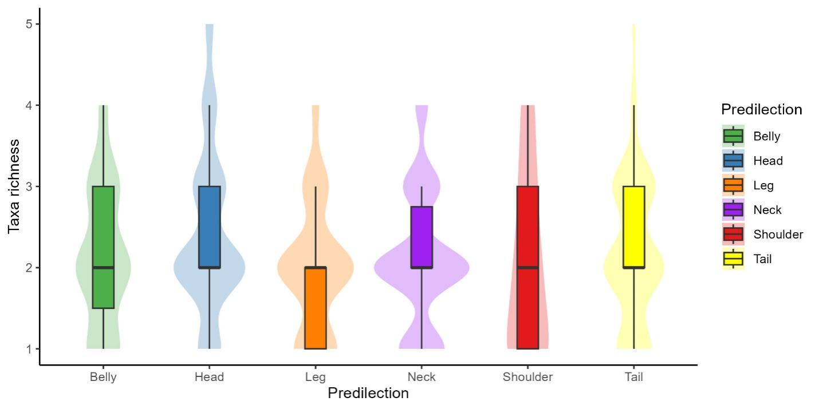

**Fig. 9** Species richness of ticks at the predilection areas in cattle sampled.

Fig. 10 presents Margalef diversity estimates of ticks across the predilection sites. Although the index did not show significant variation (p > 0.05), slight differences were observed. The head exhibited the highest mean Margalef index (0.84 ± 0.07), followed by the tail (0.65 ± 0.07), neck (0.64 ± 0.07), belly (0.64 ± 0.07), and shoulder (0.62 ± 0.13). The legs recorded the lowest Margalef index (0.57 ± 0.06) among all predilection sites.

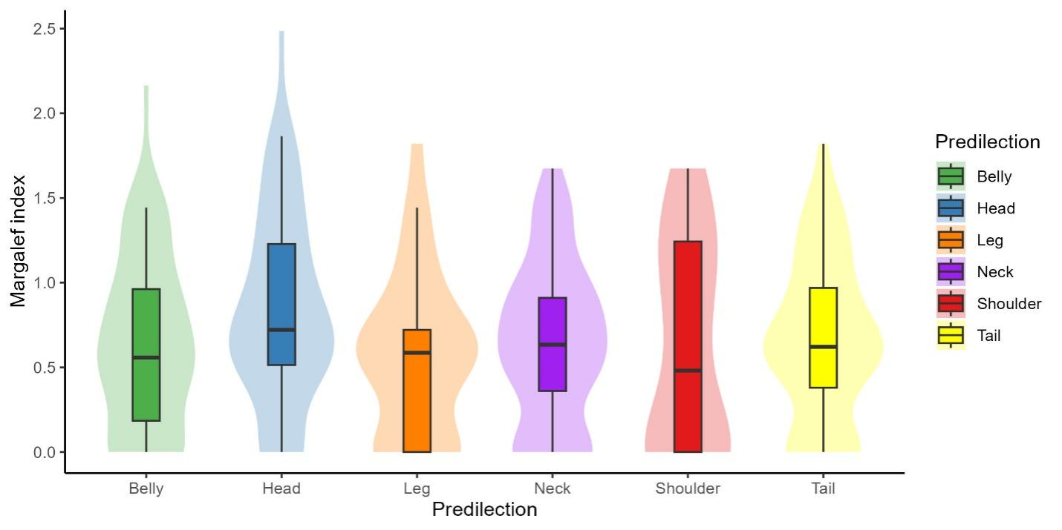

**Fig. 10** Margalef index of ticks at the predilection areas in cattle sampled.

**3.6. Predilection preference of ticks**

The FAMD accounted for 47.68% of the variance in the tick data across two dimensions (26.16% and 21.52% explained by the first and second dimensions, respectively; Fig. 11). The analysis revealed notable differences in qualitative variables, including tick life stages, predilection areas, and sex. While no species-specific preferences for predilection areas were observed, distinct differences in tick species composition were evident between adult and nymph stages, as shown by their high disparity. Additionally, the neck, belly, and legs of the cattle appeared qualitatively more similar.

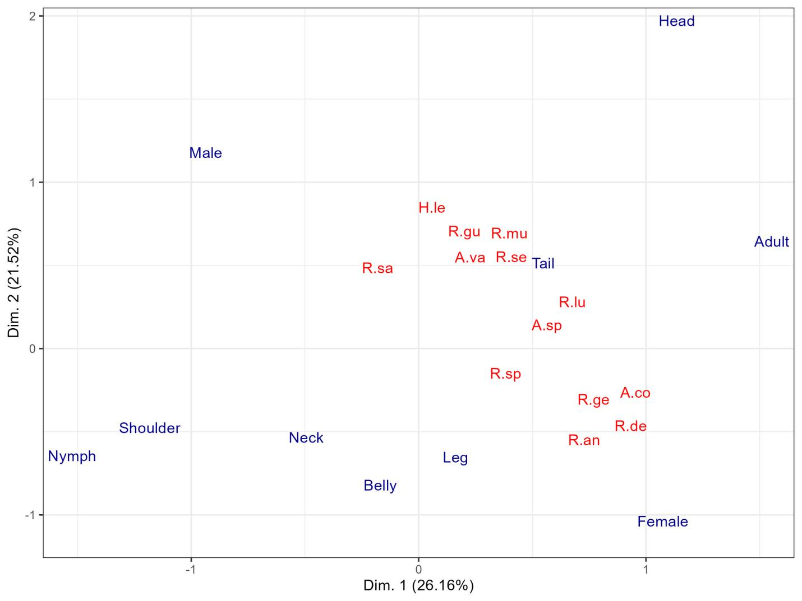

**Fig. 11**Factorial design of predilection site, life stage and species of ticks in the cattle market.A.va*, A. variegatum;* A.co*, A. cohaerens;* R.an*, R. annulatus;* B.de*, B. decoloratus;* R. ge*, R. geigyi;* H.le*, H. leachi;* R.gu*, R. gulhoni;* R.lu, *R. lunulatus;* R.mu*, R. muhsame;* R.sa*, R. sanguineus;* R.se, *R. senegalensis;* R.sp*, Rhipicephalus species;* A.sp, *Amblyomma* sp*.*

# DISCUSSION

This study investigated the prevalence of ticks at predilection sites of cattle by sampling ticks from six predilection areas of 95 cattle in a major trade market in Edo State, Nigeria. The survey revealed that 78.95% of cattle were infected with at least one tick species—a significantly higher prevalence compared to a previous report from the state (21.5%; [22]). To the best of our knowledge, this study recorded the highest diversity of ticks from a single cattle market in Nigeria, with an observed species richness of 13. Jackknife 2 estimates suggest that while a substantial number of tick species were identified, additional sampling could reveal even more species in the cattle market.

Significant changes in tick species have been observed since previous studies [22]. Our study identified 13 tick species in total, with a median of three species per host, far exceeding the three species (*A. variegatum*, *Rhipicephalus sp.*, and *R. microplus*) reported in 209 out of 258 cattle [22]. *R. annulatus*, *R. decoloratus*, and *R. geigyi* were the most abundant species in our study, constituting 42.38%, 29.38%, and 20.93% of the total ticks, respectively. Notably, the invasive *R. microplus*, which had a 21.5% prevalence in the 2019 survey [22], was absent. Similarly, a study in Maiduguri, Northern Nigeria, documented a different tick composition, including *R. microplus*, *A. variegatum*, *Hyalomma spp.*, *Rh. sanguineus*, and *Ornithodorus spp.* [33].

Most of the species of ticks that are highly prevalent in our survey are known to transmit multiple tick-borne diseases (TBDs). For example, *R.* *decoloratus*, a common tick species in Africa, is an important vector of several tick-borne livestock diseases. It transmits *Babesia bigemina* and *Anaplasma marginale* to cattle, causing babesiosis and anaplasmosis respectively [34]. Additionally, *R. annulatus* is capable of transmitting *An. marginale* through transstadial transmission, leading to anaplasmosis [35]. *R. geigyi* is recognized for its ability to transmit the protozoan parasite *Ba. bovis*, which can be detected in tick eggs, larvae, and hemolymph during various stages of infection [36]. *B. geigyi*, has been identified as a carrier of *Borrelia theileri*, the agent responsible for bovine borreliosis, in Mali [37].

The female ticks in our study exhibited greater homogeneity in community structure across all tick-infested cattle, indicating lower diversity compared to males, which showed higher diversity. However, female ticks were more numerous than males in our survey. This suggests that a few tick species dominate the female community structure. Numerous studies have demonstrated that female ticks are typically the primary carriers of TBD, as they feed for longer durations and consume more blood than males, increasing their likelihood of acquiring and transmitting pathogens [9, 10].

An increase in the female tick population elevates the risk of disease transmission to both cattle and humans. Female ticks, capable of laying thousands of eggs, contribute to a larger tick population, which raises the likelihood of future infestations and the spread of TBD [10, 38]. Although male ticks are less likely to transmit diseases due to shorter feeding durations, their diverse population, as observed in this study, may indirectly influence the ecological dynamics that enhance female ticks' survival and reproduction.

This study found that each tick-infested cattle, on average, hosted approximately three distinct tick species. The presence of multiple tick species on a single host highlights the risk of co-infections with tick-borne diseases (TBDs), as different species can transmit various pathogens. Adult ticks, due to their prolonged feeding and larger blood meals compared to nymphs, significantly contribute to disease transmission. Their prevalence on cattle underscores the heightened risk of spreading TBDs to both livestock and potentially humans.

The diversity of tick species, measured by the Margalef index, showed no significant variation across the predilection sites on cattle, indicating relatively uniform diversity across the body. This suggests that ticks may not exhibit strong preferences for specific sites, as all predilection sites—head, tail, belly, shoulder, neck and leg—had comparable levels of diversity. Furthermore, this uniformity implies that factors such as cattle movement, environmental exposure, and host immune responses likely play a more substantial role in determining tick attachment and diversity than the physical characteristics of predilection sites. Interestingly, these findings contrast with earlier studies [39], which suggested that certain body areas might be more favorable for tick attachment due to easier access or proximity to blood vessels.

A total of 13 tick species were observed, though some were rare. It is likely that further sampling would reveal additional infestations, as supported by SAC and Jackknife 2 estimates. The fact that most cattle trade market outside northern Nigeria receives cattle for sale underscores a significant public health concern. This highlights the urgent need for nationwide tick monitoring. Notably, cattle in Nigeria are predominantly raised by Hausa herdsmen, who are largely without formal education [17,18, 40, 41].

Interestingly, the invasive species *Rh. microplus* reported by Adane et al. [22] was not detected in our study. Given that the study site is a cattle market receiving cattle from the North and other distant locations, it is likely that this species has already spread across much of Nigeria. Similarly, Lorusso et al. [42] did not detect *Rh. microplus* in their central Nigeria survey. Our findings align with Lorusso et al. [42], who identified *Rh. decoloratus*, *Rh. annulatus*, *Rh. guilhoni*, and *Rh. geigy* as the most abundant species. Consistent with our results, Lorusso et al. [42] also reported a higher female-to-male ratio in these ticks, except for *Rh. guilhoni*, which exhibited a higher number of males (2.3 males: 1 female). While it is well-documented that female ticks generally outnumber males [43, 44], some studies report contrary trends in other tick taxa [13, 45, 46].

The overlap in species similarity across predilection sites suggests that ticks sampled from one area can serve as a good estimator of taxa present in another. This supports the observation of low taxon preference for specific sites. However, the same cannot be said for tick sex, as males exhibit greater taxonomic diversity compared to females. While females are more numerous, they predominantly belong to a small subset of tick species, whereas males display greater species variation.

**Limitations and Future Studies**

Smaller or immature ticks may have been missed during sampling, potentially biasing the mature-to-immature tick ratio. Additionally, the lack of data on cattle phylogeny, age, and sex limits interpretation. Factors such as cattle size, breed, age, location, and predilection site characteristics likely influenced tick abundance. Future studies are needed to explore these factors and investigate potential phylogenetic relationships that could affect tick species preferences.

**Conclusion**

This study reveals a high prevalence and diversity of tick species in cattle from a trade market in Edo State, Nigeria, with 13 species recorded and the potential for more through additional sampling. The findings indicate significant shifts in tick community composition, including the absence of *Rh. microplus* and the dominance of *R. annulatus*, *R. decoloratus*, and *R. geigyi*. The presence of multiple species per host and the predominance of female ticks—key vectors of tick-borne diseases—pose notable health risks to cattle and potentially humans. Tick diversity was consistent across predilection sites, although males exhibited greater species variation despite females being more abundant. These results underscore the need for a comprehensive, nationwide monitoring system to track tick prevalence and diversity in Nigeria, particularly given the significant role of cattle trade in spreading tick species across regions. Future research should explore tick-host dynamics through broader, standardized sampling protocols.

**Author contributions**

AOO was responsible for conceptualizing and overseeing the study, contributing sections of the manuscript, and refining the final version. NEO prepared the initial draft and carried out data analysis. NO and ABO were actively involved in conducting the research and provided input to the manuscript preparation.

**Acknowledgement**

We are deeply grateful to the Edo State Ministry of Agriculture and Food Security, Edo State, Nigeria as well as the cattle traders, for providing access to cattle for tick sample collection. Our heartfelt appreciation also goes to the University of Benin Alumni, Jamaica Branch, for their generous donation of the dissecting microscope, which was instrumental for tick species identification within the Department of Animal and Environmental Biology, Faculty of Life Sciences, University of Benin

**Data availability**

All Data and R-Scripts used in this study are openly available in this GitHub Repository: <https://github.com/Nosa-Osawe/Ticks>

**Declarations**

**Funding:** The research received no external funding.

**Clinical trial number:** Not applicable

**Competing interests:** The authors declare no competing interests.

**Ethics, Consent to Participate, and Consent to Publish:** The study was approved by the ethics committee/IRB (Ministry of Agriculture and Food Security Research and Ethical Committee (MAFSEC), Edo State, Nigeria (REF: 1041/56)). The study adhered to ethical guidelines for the care and use of animals, prioritizing humane treatment and actively minimizing any potential suffering throughout the research.

# REFERENCES

1. Rajput ZI, Hu SH, Chen WJ, Arijo AG, Xiao CW. Importance of ticks and their chemical and immunological control in livestock. J. Zhejiang Univ. Sci. B. 2006;7(11): 912–921. <https://doi.org/10.1631/jzus.2006.B0912>.
2. Randolph SE. The impact of tick ecology on pathogen transmission dynamics. Int. J. Med. Microbiol. 2008;298(S1):9–18. <https://doi.org/10.1016/j.ijmm.2007.09.007>.
3. Mollong E, Lébri M, Marie-Magdeleine C, Lagou SM, Naves M, Bambou J-C. Sustainable management of tick infestations in cattle: A tropical perspective. Parasit. Vectors.2025;18(1): Article 62. <https://doi.org/10.1186/s13071-025-06684-4>.
4. Manzano-Román R, Díaz-Martín V, de la Fuente J, Pérez-Sánchez R. Soft ticks as pathogen vectors: distribution, surveillance, and control. Parasitology. 2012;7:125–162.
5. Barré N, Uilenberg G. Spread of parasites transported with their hosts: Case study of two species of cattle tick. Rev. Sci. Tech. 2010;29(1):149–162. <https://doi.org/10.20506/rst.29.1.1968>
6. Some MV, Biguezoton AS, Githaka N, Adakal H, Dayo GK, Belem A, Moutaïrou K, Thevenon S, Chevillon C. The potential of *Rhipicephalus microplus* as a vector of *Ehrlichia ruminantium* in West Africa. Ticks Tick Borne Dis. 2023a;14(2):102117.
7. Some MV, Biguezoton AS, Zoungrana S, Zoungrana A, Belem AM. Epidemiology of heartwater disease in West Africa: Similar infection rate of *Ehrlichia ruminantium* evidenced in adults of *Amblyomma variegatum* and *Rhipicephalus microplus* in peri-urban villages of Bobo-Dioulasso, Burkina Faso. Int. J. Biol. Chem. Sci. 2023b;17(2):400–6.
8. Karbowiak G, Biernat B, Szewczyk T, Sytykiewicz H. The role of particular tick developmental stages in the circulation of tick-borne pathogens affecting humans in Central Europe. 1. The general pattern. Ann. Parasitol. 2015;61(4):221–30
9. Kamaraj C, Gandhi PR, Kumar RCS, Balasubramani G, Malafaia G. Biosynthesis and extrinsic toxicity of copper oxide nanoparticles against cattle parasites: an eco-friendly approach. Environ. Res. 2022;214:Article114009. <https://doi.org/10.1016/j.envres.2022.114009>.
10. Nasirian H. Detailed new insights about tick infestations in domestic ruminant groups: a global systematic review and meta-analysis. J. Parasit. Dis. 2022;46(2):526–601. <https://doi.org/10.1007/s12639-021-01460-4>.
11. Eskezia BG, Desta AH. Review on the impact of ticks on livestock health and productivity. J. Biol. Agric. Healthc. 2016;6(22):1–7.
12. Stachurski F. Attachment kinetics of the adult tick *Amblyomma variegatum* to cattle. Med. Vet. Entomol. 2006;20(3):317–24. <https://doi.org/10.1111/j.1365-2915.2006.00633.x>.
13. Opara MN, Ezeh NO. Ixodid ticks of cattle in Borno and Yobe states of Northeastern Nigeria: Breed and coat colour preference. Anim. Res. Int. 2011;8(1):1359–65.
14. Addo SO, Bentil RE, Mosore MT, Behene E, Adinkrah J, Tagoe J, Okyere E, Kwarteng KA, Nyarko F, Dadzie SK. Risk factors affecting the feeding site predilection of ticks on cattle in Ghana. Exp. Appl. Acarol. 2024;92(4):835–50. <https://doi.org/10.1007/s10493-024-00906-7>
15. Léger E, Vourc'h G, Vial L, Chevillon C, McCoy KD. Changing distributions of ticks: causes and consequences. Exp. Appl. Acarol. 2013;59(1–2):219–44. <https://doi.org/10.1007/s10493-012-9615-0>.
16. Nyangiwe N, Yawa M, Muchenje V. Driving forces for changes in geographic range of cattle ticks (*Acari: Ixodidae*) in Africa: A review. S. Afr. J. Anim. Sci. 2018;48(5):829–41. <https://doi.org/10.4314/sajas.v48i5.9>.
17. Sulaiman IM, Moses JD. Livestock farming and its economic contributions in Nigeria. International J. Livest. Stud. 2024;15(2):89–102. https://doi.org/10.5678/ijls.v15i2.7890.
18. Adamu A, Jatau ID. The socio-economic impact of livestock farming in Nigeria. J. Agric. Econ. Dev. 2023;12(3):45–58. <https://doi.org/10.1234/jaed.v12i3.5678>
19. Mafimisebi TE, Bobola OM, Mafimisebi OE. Fundamentals of cattle marketing in southwest Nigeria: Analyzing market intermediaries, price formation, and yield performance. Proc. Afr. Assoc. Agric. Econ. (AAAE) 4th International Conference. Hammamet, Tunisia. 2013. <https://doi.org/10.22004/ag.econ.161462>.
20. Ugochukwu SO, Agu GC, Okocha AC. Current concepts in the control of ticks and tick-borne diseases in Nigeria—A review. Int. J. Trop. Insect Sci. 2018;38(2):71–8. <https://doi.org/10.1017/S1742758418000063>.
21. Sulaiman IM, Adamu A, Jatau ID. Current distribution and disease association of Ixodidae (hard ticks) in Nigeria. J. Basic Appl. Zool. 2022;83(1):Article 13. <https://doi.org/10.1186/s41936-022-00304-8>
22. Adane IO, Okaka CE, Aiwaritoma AO, Osagie PA, Igetei JE. Prevalence and seasonal variation of ticks in trade cattle consumed in Edo State, Nigeria. Int. J. Zool. Stud. 2019;4(5):21-6.
23. Ghosh S, Azhahianambi P, Yadav MP. Upcoming and future strategies of tick control: A review. J. Vector Borne Dis. 2007;44(2):79–89.
24. Estrada-Peña A, De la Fuente J. The ecology of ticks and epidemiology of tick-borne viral diseases. Antivir. Res. 2014;108:104–28. <https://doi.org/10.1016/j.antiviral.2014.05.016>
25. John-Abebe RO, Oboh EE, Osirike AB. Population growth and migration pattern in the Benin Region, Nigeria. J. Geogr. Thought Environ. Stud. 2021;16(1):224–234.
26. Floyd AC, Oikpor R, Ekene B. An assessment of climate change in Benin City, Edo State, Nigeria. FUTY J. Environ. 2016;10(1):87–94.
27. Walker AR, Bouattour A, Camicas J-L, Estrada-Peña A, Horak IG, Latif AA, Pegram RG, Preston PM. Ticks of Domestic Animals in Africa: A Guide to Identification of Species. Bioscience Reports, Edinburgh Scotland, U.K. 2014. Sponsored by ICA4-CT-2000-30006, entitled, International Consortium on Ticks and Tick Borne Diseases (ICTTD-2).
28. Okello-Onen J, Hassan SM, Essuman S. Taxonomy of African Ticks: An Identification Manual. ICIPE Science Press, Nairobi; 1999.
29. Hammer Ø, Harper DAT. Paleontological data analysis. 2nd ed. John Wiley & Sons; 2024.
30. Venables WN, Ripley BD. Modern Applied Statistics with S. 4th ed. Springer; 2002.
31. Hothorn T, Bretz F, Westfall P. Simultaneous inference in general parametric models. Biometrical J. 2008;50(3):346–363. <https://doi.org/10.1002/bimj.200810425>.
32. Kassambara A, Mundt F. Factoextra: Extract and Visualize the Results of Multivariate Data Analyses. R package version 1.0.7; 2020. Retrieved from <https://CRAN.R-project.org/package=factoextra>.
33. Musa H, Jajere S, Adamu N, Atsanda N, Lawal J, Adamu S, Lawal E. Prevalence of tick infestation in different breeds of cattle in Maiduguri, Northeastern Nigeria. Bangladesh J. Vet. Med. 2014;12(2):161–6. <https://doi.org/10.3329/bjvm.v12i2.21279>.
34. Akinboade OA, Dipeolu OO, Adetunji A. Experimental transmission of *Babesia bigemina* and *Anaplasma marginale* to calves with the larvae of *Boophilus decoloratus*. Zentralbl. Vet. Med. B 1981;28(4):329–32. <https://doi.org/10.1111/j.1439-0450.1981.tb01806.x>
35. Samish M, Pipano E, Hadani A. Intrastadial and interstadial transmission of *Anaplasma marginale* by *Boophilus annulatus* ticks in cattle. Am. J. Vet. Res. 1993;54(3):411–4.
36. Akinboade OA, Dipeolu OO. Detection of *Babesia bovis* infections in *Boophilus geigyi* with egg crushings, larval smears, and haemolymph puncture. Vet. Q. 1981;3(3):143–7. <https://doi.org/10.1080/01652176.1981.9693794>.
37. McCoy BN, Maïga O, Schwan TG. Detection of *Borrelia theileri* in *Rhipicephalus geigyi* from Mali. Ticks Tick Borne Dis. 2014;5(4):401–3. <https://doi.org/10.1016/j.ttbdis.2014.01.002>.
38. Nabbout AE, Ferguson LV, Miyashita A, Adamo SA. Female ticks (*Ixodes scapularis*) infected with *Borrelia burgdorferi* have increased overwintering survival, with implications for tick population growth. Insect Sci. 2023;30(6):1798–809. <https://doi.org/10.1111/1744-7917.13176>.
39. Kabore H, Salembere MS, Tamboura HH. Seasonal variation of ticks on cattle in Burkina Faso. Ann. N. Y. Acad. Sci. 1998;849(1):398–401. <https://doi.org/10.1111/j.1749-6632.1998.tb11166.x>.
40. Adisa RS, Badmos AHA. Socioeconomic correlates of perceptions of sustainability of pastoral livelihood among cattle herdsmen in Kwara State, Nigeria. Agrosearch. 2010;10(1–2):21–30. <https://doi.org/10.4314/agrosh.v10i1.69812>
41. Arowolo OO, Lawal AM, Ogundijo JI. Grass-root youth involvement in cattle rearing activities in Oyo State, South Western Nigeria. J. Agric. Ext. Rural Dev. 2013;5(5):100–6. <https://doi.org/10.5897/JAERD12.088>
42. Lorusso V, Picozzi K, de Bronsvoort BM, Majekodunmi A, Dongkum C, Balak G, Thrusfield M, Welburn SC. Ixodid ticks of traditionally managed cattle in central Nigeria: Where *Rhipicephalus* (*Boophilus*) *microplus* does not dare (yet?). Parasit. Vectors 2013;6(1):171. <https://doi.org/10.1186/1756-3305-6-171>.
43. Kiffner C, Lödige C, Alings M, Vor T, Rühe F. Abundance estimation of *Ixodes* ticks (Acari: Ixodidae) on roe deer (*Capreolus capreolus*). Exp. Appl. Acarol. 2010;52(1):73–84. <https://doi.org/10.1007/s10493-010-9341-4>.
44. Rehman A, Nijhof AM, Sauter-Louis C, Schauer B, Staubach C, Conraths FJ. Distribution of ticks infesting ruminants and risk factors associated with high tick prevalence in livestock farms in the semi-arid and arid agro-ecological zones of Pakistan. Parasit. Vectors. 2017;10(1):190. <https://doi.org/10.1186/s13071-017-2138-0>.
45. Golo D, Wubishet Z, Tadelle S, Kula J, Gete G, Garu L. Composition, prevalence and abundance of Ixodid cattle ticks at Ethio-Kenyan Border, Dillo district of Borana Zone, Southern Ethiopia. J. Vet. Med. Anim. Health. 2017;9(8):204–12. <https://doi.org/10.5897/JVMAH2017.0589>.
46. Isaac C, Igbinosa IB, Nmorsi OPG. Parasites and pathogens of ticks (*Rhipicephalus* species Acari: Ixodidae) among dogs in Edo State, Nigeria. Niger. J. Parasitol. 2016;37(2):129–34. <https://doi.org/10.4314/njpar.v37i2.2>.